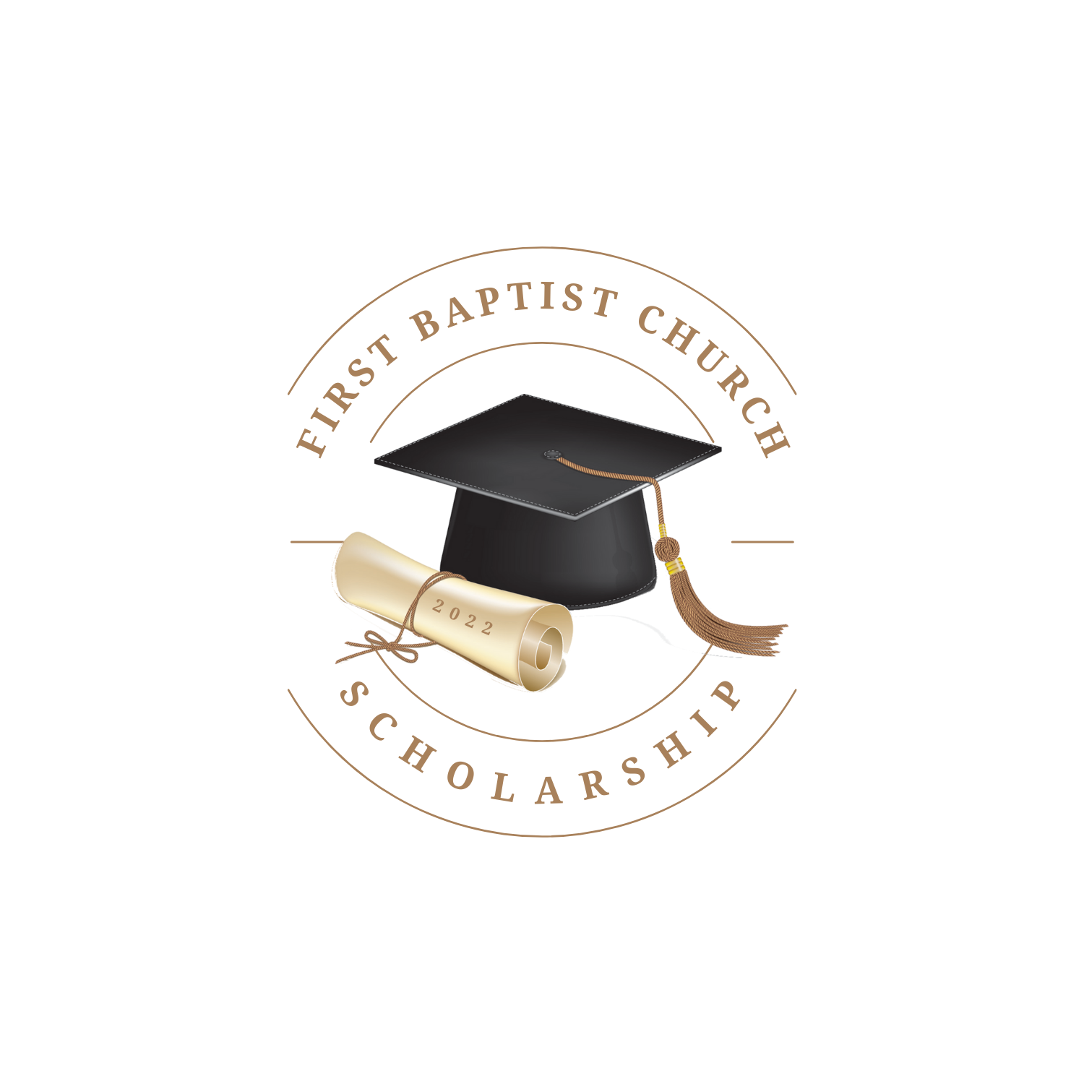

The First Baptist Church of Brentwood

Scholarship Application 2023

Included in this packet are 3 sections

- Criteria for Scholarship explaining who is eligible to be considered as a Scholarship recipient.
- Application regarding school you have been accepted to and field of intended study.
- Questionnaire when answered helps us get to know you better.

Please Note:
- Incomplete application/ questionnaire will likely result in disqualification by the Scholarship Committee.
- You may complete the Application/ Questionnaire using blue or black inked pen or typing answers into the document itself. If typing on a separate sheet of paper please reference information on the Application/ Questionnaire prior to response.
- Handwriting must be legible.
- Completed Application/ Questionnaire are due to arrive at The First Baptist Church Brentwood no later than April 26, 2022. The Scholarship Committee will meet shortly after that date to review the Applications and determine Scholarship Recipient.
- If two or more Applicants are equal and determining one over another is very difficult, the Scholarship Committee may decide to divide the award funds among them.

*Not included in this packet are two letters of recommendation/ reference. See more information in Criteria Section.

The First Baptist Church of Brentwood

Criteria for Scholarship 2023

Receipt of scholarship is available to any High School Senior under the following guidelines:

- The student must be a resident of New Hampshire.
- The student must be in good standing at a New Hampshire high school, either public or private, or a home school student.
- Invitations to apply will be sent only to Sanborn Regional High School, Exeter Area High School and Epping High School. However other students who are related to the First Baptist Church members and attendees will also be considered, provided the applicant is a blood relative, no further removed from said member or attendee by more than two generations.
  - For instance, Jane Doe attends Pinkerton Academy in Derry, but does not attend church services in Brentwood. On her own she would not be eligible, but she is the granddaughter of June Doe (a church member), which makes her eligible.
  - It is not required that an applicant be a member or attendee of First Baptist Church. However, such fact may be taken into consideration by the Committee.
  - For example, Joe Dokes is a Senior at Exeter Area High School. He attends First Baptist Church occasionally, but not regularly; however, his parents are church members, so he is eligible by virtue of being a student at Exeter, but also due to his parents’ membership and his own attendance.
    - If, after all the other things are taken into consideration Jane and Joe are considered equally qualified, the choice should go to Joe, as an occasional attender.
- Applying students will be required to submit two letters of recommendation from schoolteachers and/ or administrators, as well as answer a questionnaire. In addition to this questionnaire is a required an answer to the question, Why do you believe yourself worthy of this scholarship?”
- The amount of this annual scholarship may vary from year to year, but for 2021 the amount was $2,000 (two thousand dollars).
- Completed applications must be received no later than April 20, 2022. The completed application, letters of recommendation and questionnaire are to be returned to:

The First Baptist Church Brentwood
201 North Road
Brentwood, NH 03833
Attn: Scholarship Committee

If you need further information or instruction, please contact Rev. Jim Barnes at (603) 679- 5259

The First Baptist Church of Brentwood
Application & Questionnaire
Scholarship 2023

Personal Information
Name: |  | School Graduating From:
Mailing Address
City |  | State |  | Zip Code
Date of Birth |  | Telephone

College Information
Accepted at name (College, University or Trade School):
Declared Major or course of study:

Please fill out each question to the best of your ability:

Why do you believe yourself to be a worthy recipient of this scholarship?
Please detail your involvement with non- school sponsored groups or organizations during your time in High School.
Please identify any hobbies and/ or special interests that you pursue on your own, apart from group activities.
In what field do you plan to pursue your degree or certification and why?
Given that you had no restrictions at all, what is your greatest dream for your future?

